Menus
With the exception of the login page, every view component will have an identical menu bar fixed to the top of the web page and another at the bottom of the page. Since the site’s name is JMU Share, we will keep the colors restricted to the JMU colors and white. A quick google search gives us the school colors. Along with the two colors below, we’ll use white (#FFFFFF) as a consistent background for the notes and a light grey (#DDDDDD) to provide a similar feel to common text editors like MS word, libre office, and google docs.
Colors
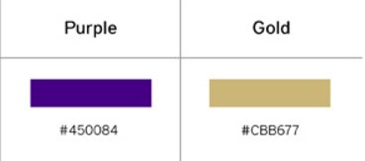

As shown below, the selected page on the top menu bar will be gold colored. When a link on the bar is active it will glow darker. Listed are the four main pages of our website. These pages will have a similar look to the example page provided below with the same colors and fonts.

Top menu bar
The bottom menu bar has the same style as the top bar but only has the about link. Once the application has more publishing information that we want to share we’ll add it to this bar in the center.

Bottom menu bar
Headings
Headings will be kept left justified like all text. The h1 heading will be reserved for the titles of notes which describe the note contents. The h2 heading will be used for the start of the comments sections, and the meta data about notes like class, term, and teacher. The h3 heading will be used for the other data related to notes including author, date submitted, and all of the search results data. Since search results need to have smaller text to fit more results in one page, all information about notes aside from the title will be set to the h3 heading size. The paragraph tags will be reserved for the content of notes making it easy to skim past the plain paragraph text when looking for descriptor information in bold headings.

Logos
Once we decide on a logo, it will be included in the “Home” section of the menu bar. It will still link to the homepage but it will be an image in the place of the text. We’ll also put the logo in the center of the bottom bar.

Examples
This example of a notes page provides basic examples of most of the content on the site. The sections on all the pages will be wrapped with this gray border. The search results will be separated from the search form contents above, and profile information will be separated from user posting links listed below them. The top bar will always be visible but if the content is large enough, the bottom bar will be pushed off the end.

Notes page
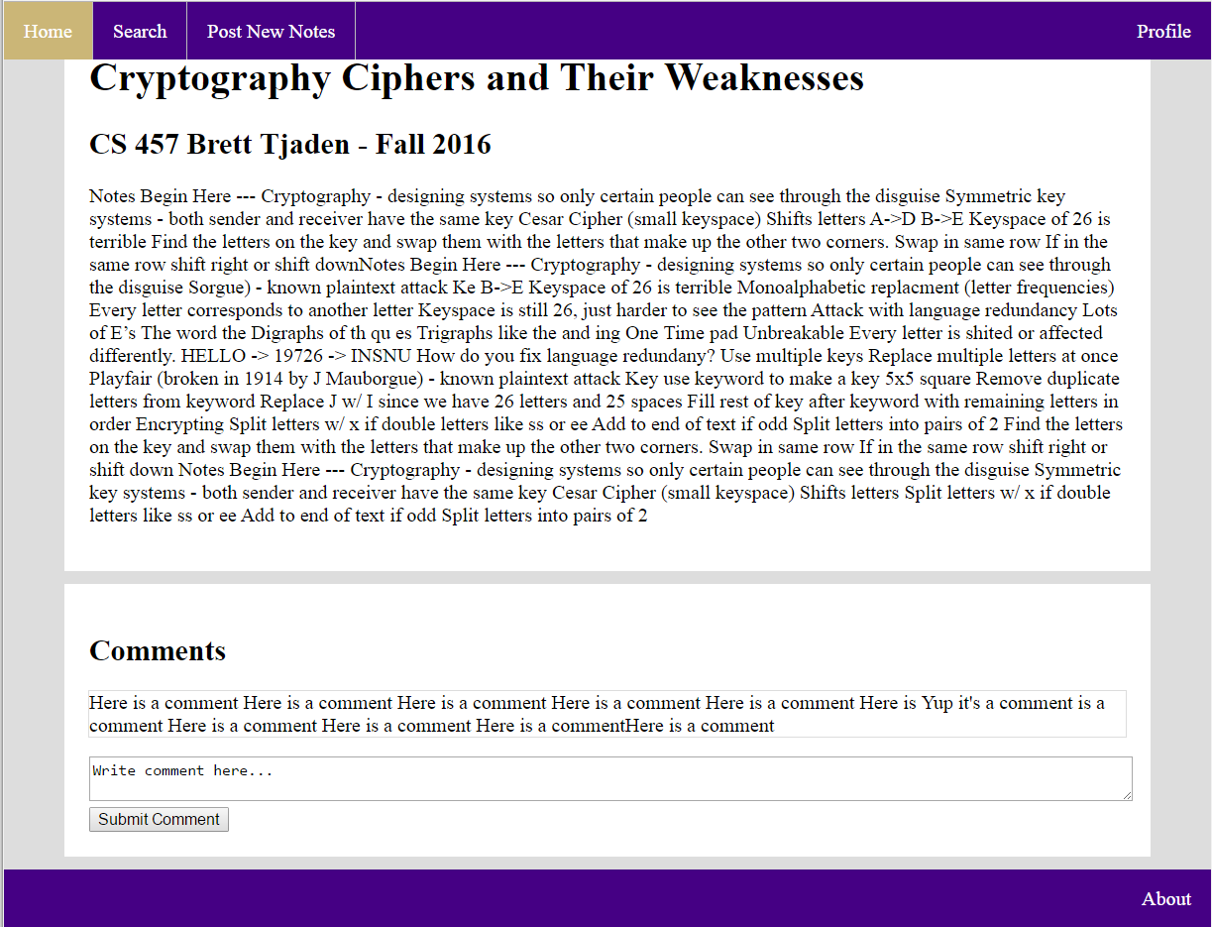

For the other examples, I have created them in photoshop instead of an html editor so they don’t have valid css formatting. I just manually created them real quickly as creating the pages in html would be completing most of the project. The notes example above required enough design decisions to be made that I determined that making the rest of the examples real pages was unnecessary. They certainly show what the user interface should look like.
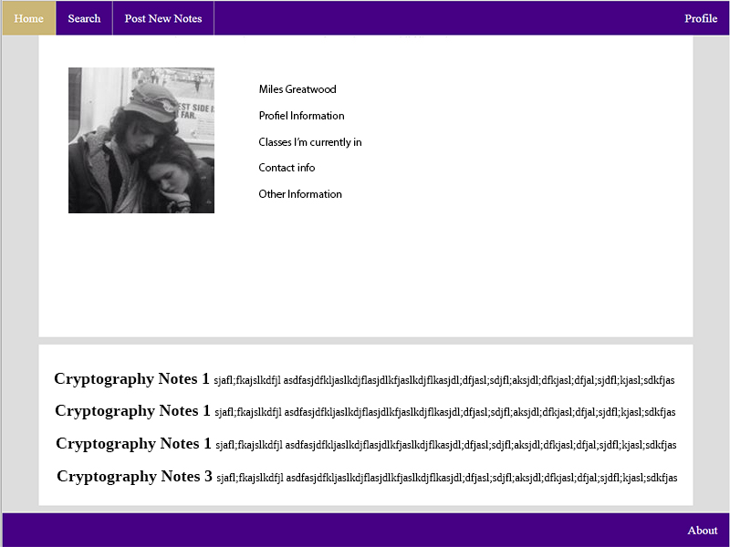
Profile page
Search page
